Winter Series 2017 – 2018
Races include:
□ November 4, 2017 – HC Turkey Trot 5K 9 am
□ December 16, 2017 - Big Dog Jingle 5K 9 am
□ January 13, 2018 - MLK 5K ___ 10K ___ 10 am (check one)
□ February 3, 2018-SuperBowl 5K __ / □10K__10 am -REQUIRED
Check the races you plan to run and the distance on the MLK &SuperBowl race
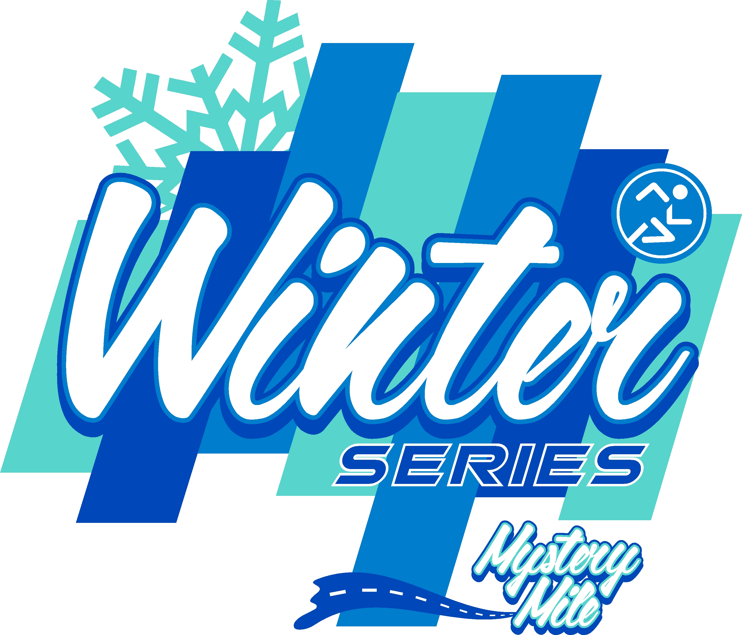

Registration Fees (check the box that applies): □$80 CRR Members □$95 Nonmember
Prices include entry into all races, shirt or goodie for races plus a Winter Series Shirt, chip timing & Awards.
Awards: Runners must run 3 out of 4 of the races (the SuperBowl 5K/10K is required) to be eligible for Series Awards. Series awards will be given at the end of the Series along with a Celebration Party in February. There will be Awards for top 3 overall, Masters, winner in 10 year age groups - all male & female - based on a point system. A medal will be awarded to everyone completing all 4 races. Each race will have a Mystery Mile Award.
Registration: Register at Big Dog Running Co store, complete this form & mail to the address below, or register online at RunSignUp.com.
First name: _______________________ Last Name: _____________________
Address: _______________________________ City: _________ State: ____ Zip: _______
Date of Birth: _________ □ Male □ Female Phone: ____________ Email: ______________
Shirt Size (please check one): Men: □ Small □ Medium □ Large □ X-Large □ XXL
Women: □ Small □ Medium □ Large □ X-Large
Youth: □ Small □ Medium □ Large
Mail completed & signed entry form with payment to:
Columbus Roadrunners
POB 9734
Columbus Ga 31908
Waiver/Release Statement (please read and sign below):
In consideration of acceptance of this entry, I hereby, for myself, my heirs, my executors, and administrators, waive any and all rights and claims for illness, injuries, or damages I may have against the Columbus Roadrunners, and it’s officers, directors, and members, volunteers, employees, agents, sponsors or race director. None of the above is responsible for loss of personal items, or any form of aggravation in connection with said event. I fully understand that my participation is a completely voluntary undertaking of my own choosing and I fully understand that in doing so I assume full responsibility for all damages or injuries incurred by me in connections with this event. I give permission for the free use of my name or photograph in any broadcast or print account of this event. I am in proper physical condition to participate in this event. I certify that I carefully read this release and know the contents.
Participant’s Signature: ______________________________________________________________________________
Parent/guardian if participant is under 18 years old: ________________________________________________________

