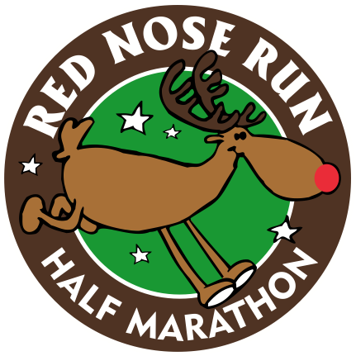

**12th Annual**

**Red Nose Half Marathon**

**Saturday, Jan 6, 2018**

**8 am**

**Mail completed & signed entry form with payment to:**

**Columbus Roadrunners**

**POB 9734**

**Columbus Ga 31908**

Participant’s Signature: ______________________________________________________________________________

Parent/guardian if participant is under 18 years old: ________________________________________________________

**Waiver/Release Statement (please read and sign below):**

In consideration of acceptance of this entry, I hereby, for myself, my heirs, my executors, and administrators, waive any and all rights and claims for illness, injuries, or damages I may have against the Columbus Roadrunners, and it’s officers, directors, and members, volunteers, employees, agents, sponsors or race director. None of the above is responsible for loss of personal items, or any form of aggravation in connection with said event. I fully understand that my participation is a completely voluntary undertaking of my own choosing and I fully understand that in doing so I assume full responsibility for all damages or injuries incurred by me in connections with this event. I give permission for the free use of my name or photograph in any broadcast or print account of this event. I am in proper physical condition to participate in this event. I certify that I carefully read this release and know the contents.

**Where:** 12th & Broadway

**Course:** The 13.1 mile CERTIFIED course starts & finishes at 12th & Broadway & follows the scenic Riverwalk

**Cost:** FREE! There is an optional long sleeve technical shirt offered to runners at a cost of $25

To be guaranteed a shirt must receive payment by Dec 15, extras will be ordered (1st come basis)

**Awards: Top 3 overall, masters – male & female, age group 10 year male & female 1st - 3rd**

**Registration:** Register at Big Dog Running Co store, complete this form & mail, or go online to www.columbusroadrunners.com

First Name:______________________________ Last Name:________________________________________

Address:_________________________________ City:_____________________ State:____ Zip:___________

Date of Birth:__________ Male:__ Female:__ Phone:______________ Email:___________________________

Shirt Size (Please check one): Mens: Small____ Medium____ Large____ X-Large____ XXL____

OR Womens: Small____ Medium____ Large____ X-Large____